Instructions for submitting your application for the University Libraries Lance & Elena Calvert Undergraduate Research Award
http://www.library.unlv.edu/award/

There are three steps to the online application process.
- Create an account (it’s free!)
- Describe & upload your project
- Upload supplemental content (e.g. additional required application documents)

You may find it helpful to have this document visible while you work through the submission process. Either print this document or have it open in a separate browser window.

From the Award webpage find the link to Submit Your Application or use this address: http://tinyurl.com/UNLVCalvertAward

Step One: Create an Account
  - Under Create New Account click the Sign up button.
  - Fill in the form. Your e-mail address will be your account name; create a password.
For Institution Name please type out the complete name University of Nevada Las Vegas. Do not use UNLV or other abbreviations.
  - When you click the Sign up button you will be instructed that an email will be sent to you with a link that you must click to complete your account activation. Please open your email account, find that email, and click on the link. The link will take you to a webpage where you will see My Account information. Please edit your account profile to add your phone number.

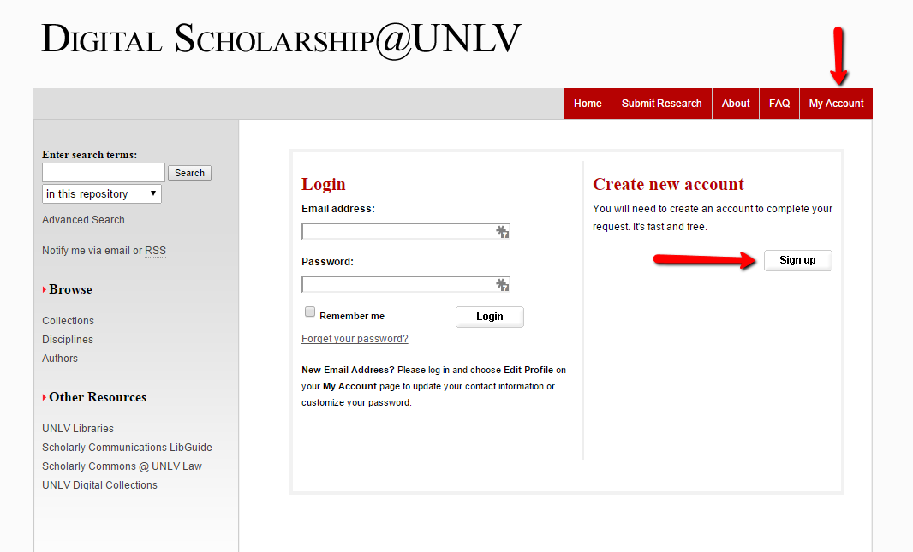
Step Two: Describe & Upload Your Project (Thesis, Research Paper or Creative Work)

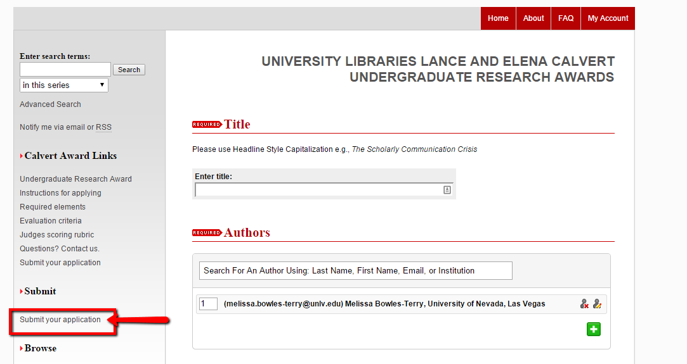
- Use the Submit your application link (lower left on screen). Make sure that, at the top of the screen, you see University Libraries Lance and Elena Calvert Award for Undergraduate Research.
- The form requires title and other identifying information about your project. You may want to have a second window open on your computer desktop to copy/paste information into the onscreen submission form from your project or application documents. The form has some fields that may be irrelevant to your project. Be sure to complete the fields below (at a minimum):
- Title: Enter title of paper/project. Copy/paste if you like. Check formatting of characters
- Authors: For group projects, enter names of all group members as co-authors.
- Document type: Select best match from pull down menu.
- Publication date: Add year only (month/day not required). Use the year the project was submitted for coursework.
- Abstract: Copy/paste or type up to 250-word summary of your project.
- Keywords: Enter no more than 10 words describing your project.
- Disciplines: Select best choices from the list provided. Highlight term and click Select button.
- Comments: Provide any explanation of files (format or relationships) you think the judges will need to know to be able to view and evaluate your project. (e.g. software requirements for viewing, relationships of multiple files, etc.)
- Creative Commons License: Choose a license that suits your needs. The link provided (http://creativecommons.org/about/) explains the license options. Creative Commons licenses complement copyright and provide a simple, standardized way to give the public permission to share and use your creative work.
- Repository Citation: This is optional, and typically left blank.
- Upload file: Choose an action based on the location of your file. IMPORTANT: The file to upload here MUST be the project itself (thesis, research paper, design, etc.). There is a place to add other application materials later in the online submission process.

If submitting a creative work, only submit the creative work itself. If it was completed for an honors course, the accompanying thesis will not be considered for the project; the research process must be described in the research essay.
- Additional files: Be sure to check the box so you will have the option to add the additional required documents, e.g. cover sheet, research essay, letter from faculty.
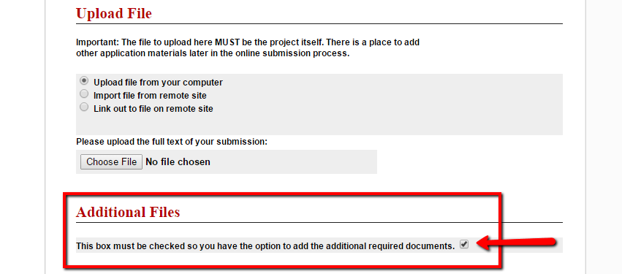
- Click the Submit button and wait for system response.

Step Three: Upload Supplemental Content
- When the Submit process has completed processing you will upload the other application documents. The screen should look like the image below:

If you do not see this screen, go to the end of this handout for Troubleshooting instructions.

Please note that you must upload each additional document individually.

- cover sheet for your application
- a 500-750 word essay describing and reflecting upon your research process and use of resources
- a 250-500 word artist statement (if submitting a creative work) describing the overall meaning of the work, techniques and resources used, and how specific influences or inspirations shaped the piece
- a bibliography for your project if not included with your project uploaded on the previous page
- a letter of support from the faculty member or instructor of the course for which the research was completed.
- a cover sheet for the faculty letter of support
- For each document uploaded, please provide a short description of each document in the box provided, e.g. Application cover sheet, Research essay, Faculty letter cover sheet, etc.
- Click Save File for each document.
- Click Continue button after all documents of your application have been added.
You will then see a green notice of successful submission. We strongly recommend that you print the summary statement which will list all the documents you submitted.
You will also receive an e-mail confirmation that you submitted your documents.
You can revisit your account to add to or revise your submission until April 20, 2022 at 5:00 p.m.
The University Libraries will notify you by e-mail when your application is complete. However, the status that will display in your online account will remain listed as “under review.”
Feel free to contact amber.sewell@unlv.edu with any questions.

Troubleshooting:
If you see this screen instead of that pictured at Step 3 Upload Supplemental Content: 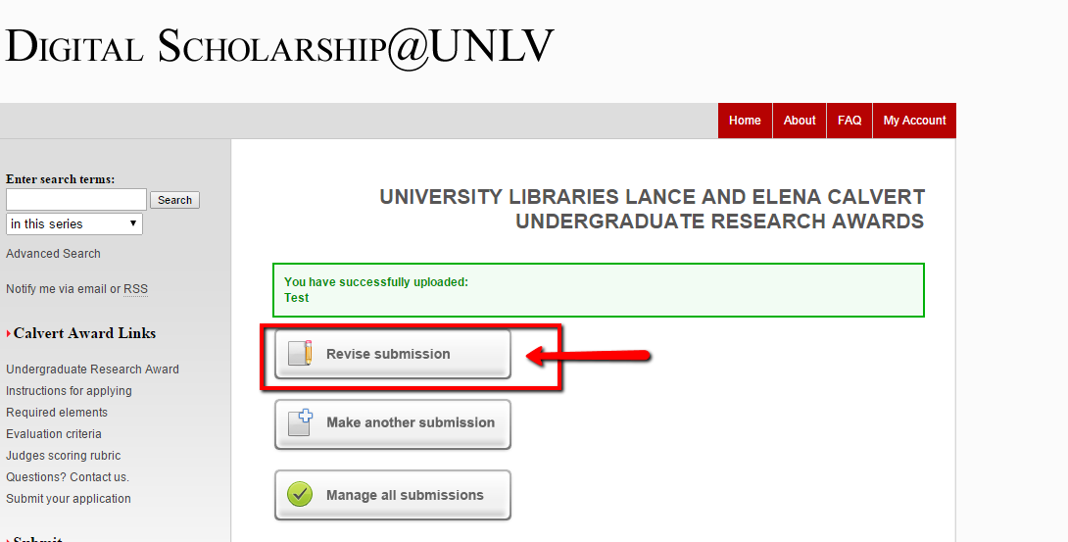
You did not select “Additional Files,” and you need to revise your submission.
To complete your application, click the Revise Submission button, scroll to the bottom of the screen to find the section for Additional Files, add a check to the small box and click on the Submit button. Return to Step Three of this handout to continue.

