View Fairfield Beach: The Library online at
http://faculty.fairfield.edu/mediacenter/library/

Recommended Reading
- Understanding students' perceptions and experiences concerning information use
  - Bates, J. A. (2004). Use of narrative interviewing in everyday information
behavior research. Library and Information Science Research, 26(1), 15-28.
  - Maybee, C. (2006). Undergraduate perceptions of information use: The basis for
creating user-centered student information literacy instruction. The Journal of
Academic Librarianship, 32(1), 79-85.
- Information literacy teaching and outreach through movie making
  - Islam, R. & Porter, L. (in press). Perseverance and play: Making a movie for the
YouTube generation. Urban Library Journal.
  - Jacobson, G. N., & Albright, M. J. (1983). Motivation via videotape: Key
to undergraduate library instruction in the research library. The Journal
of Academic Librarianship, 9(5), 270+
  - Mizrachi, D., & Bedoya, J. (2007). LITE bites: broadcasting bite-sized library
instruction. Reference Services Review, 35, 249-256.
- Using clickers in the library instruction classroom
  - Hoffman, C., & Goodwin, S. (2006). A clicker for your thoughts: Technology for
active learning. New Library World, 107(9/10), 422.
  - Collins, L. J. (2007, Spring). Livening up the classroom: using audience response
systems to promote active learning. Medical Reference Services Quarterly,
pp. 81-88.
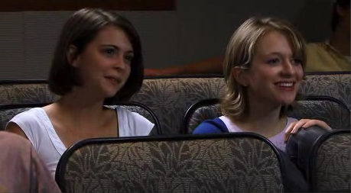

The Students Are the Stars: Making a (Subversively Instructional) Interactive Movie
Ramona Islam - Senior Reference Librarian and Instruction Coordinator, Fairfield University
Leslie Porter - Reference Librarian, Robert W. Woodruff Library at Atlanta University Center

