The Students Are the Stars: Making a (Subversively Instructional) Interactive Movie
- Ramona Islam - Senior Reference Librarian and Instruction Coordinator, Fairfield University
- Leslie Porter - Reference Librarian, Robert W. Woodruff Library at Atlanta University Center

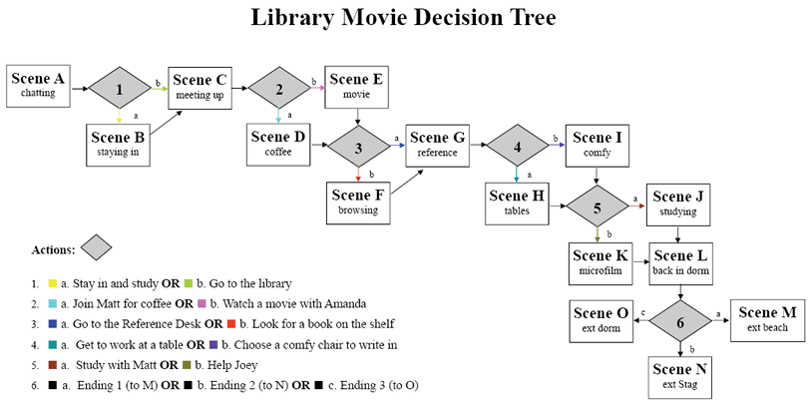

View Fairfield Beach: The Library at http://faculty.fairfield.edu/mediacenter/library/

